PRACTICAL NO.: - 9

# NAME : GULAM JAWWAD KHAN

# ROLL NO.: 43

# SECTION: 3A

AIM : Study and Installation of Weka AI tool

# Objective:

- Understand the functionalities and features of Weka.  
- Learn how to install and run Weka on a local machine.  
- Explore its GUI interface for machine learning tasks like classification, clustering, and data preprocessing.

# Theory:

Weka (Waikato Environment for Knowledge Analysis) is an open-source software developed at the University of Waikato, New Zealand. It is a powerful suite of machine learning algorithms for data mining tasks, written in Java. Weka contains tools for:  
- Data Preprocessing  
- Classification  
- Clustering  
- Association Rule Mining  
- Visualization  
  
Weka provides a Graphical User Interface (GUI), making it ideal for beginners to explore machine learning models without coding.

# Software Requirements:

- Operating System: Windows/Linux/Mac  
- Java Runtime Environment (JRE)  
- Weka 3.x (latest stable release from the official website)

# Installation Steps:

1. Install Java (if not already installed):  
 - Download Java JDK from: <https://www.oracle.com/java/technologies/javase-downloads.html>

- Install it and set the environment variables if needed.  
  
2. Download Weka:  
 - Go to the official Weka site: <https://www.cs.waikato.ac.nz/ml/weka/>

- Download the `.exe` or `.jar` file suitable for your system.  
  
3. Run the Installer:  
 - Install Weka by running the setup file.  
 - For `.jar`, open it using `java -jar weka.jar`.  
  
4. Launch Weka GUI:  
 - After installation, open Weka.  
 - You will see different panels like Explorer, Experimenter, Knowledge Flow, and Simple CLI.

# Screenshots of Installation & GUI:

Below are the screenshots taken during the installation and exploration of Weka:

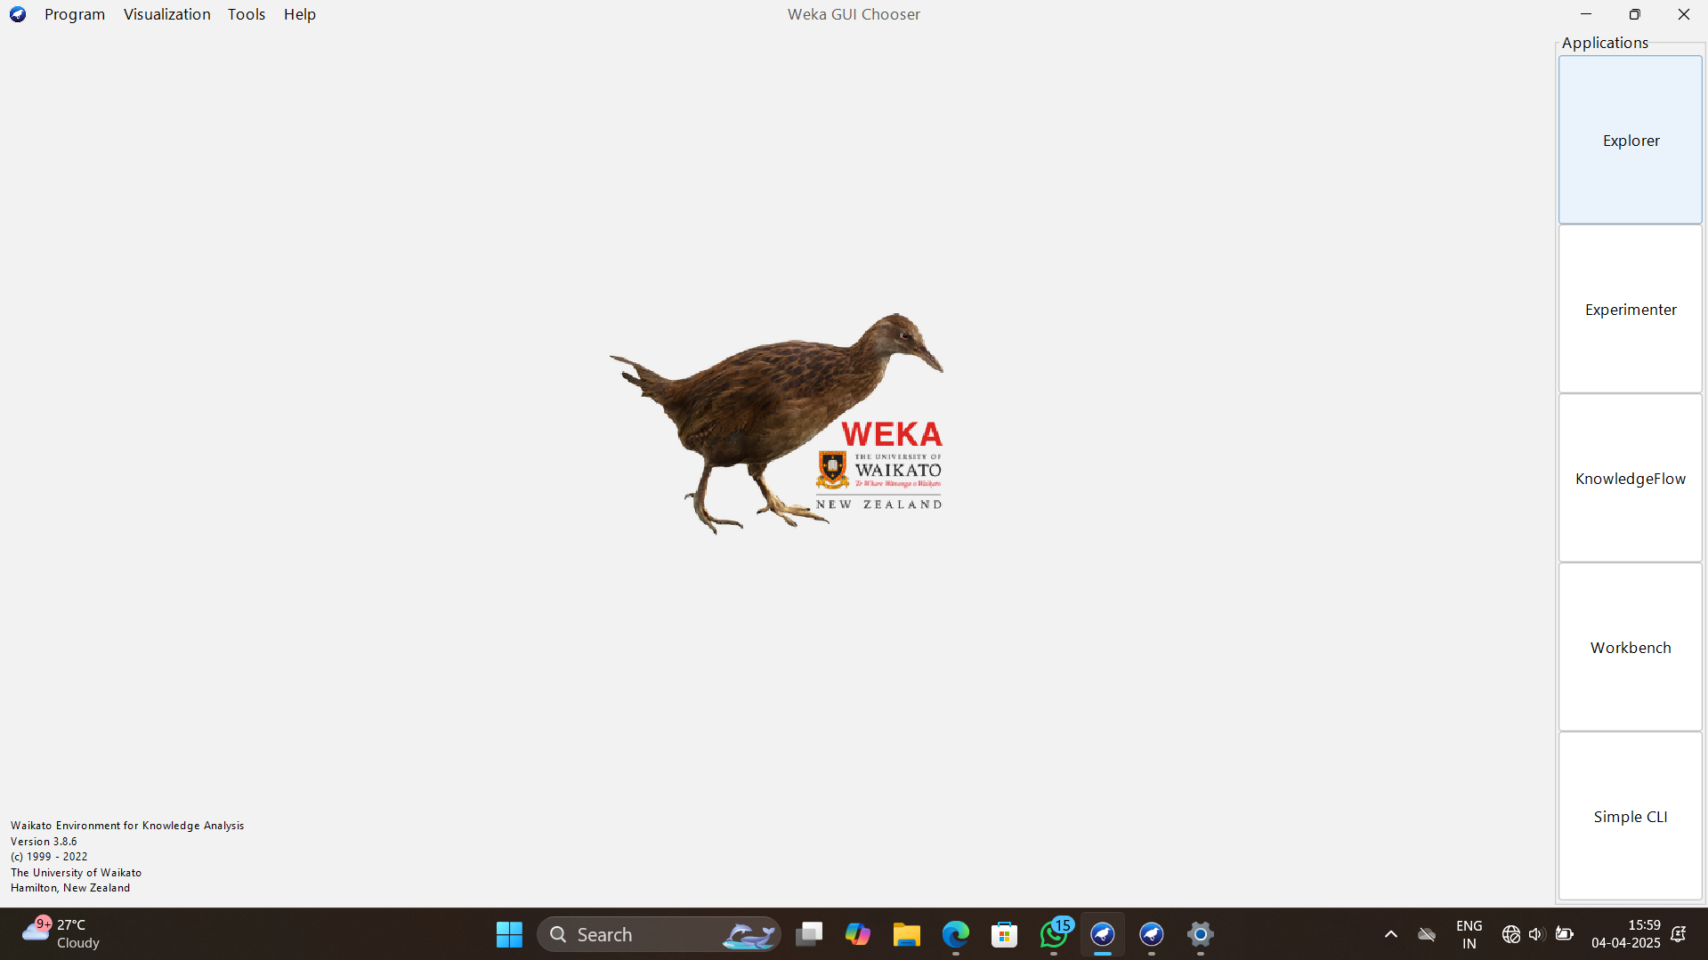

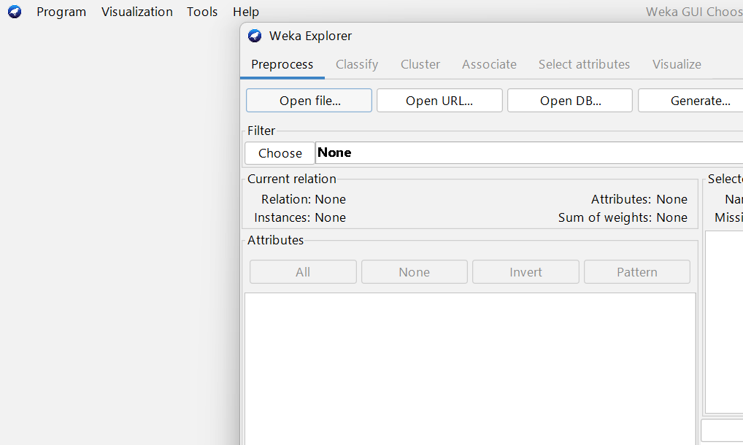

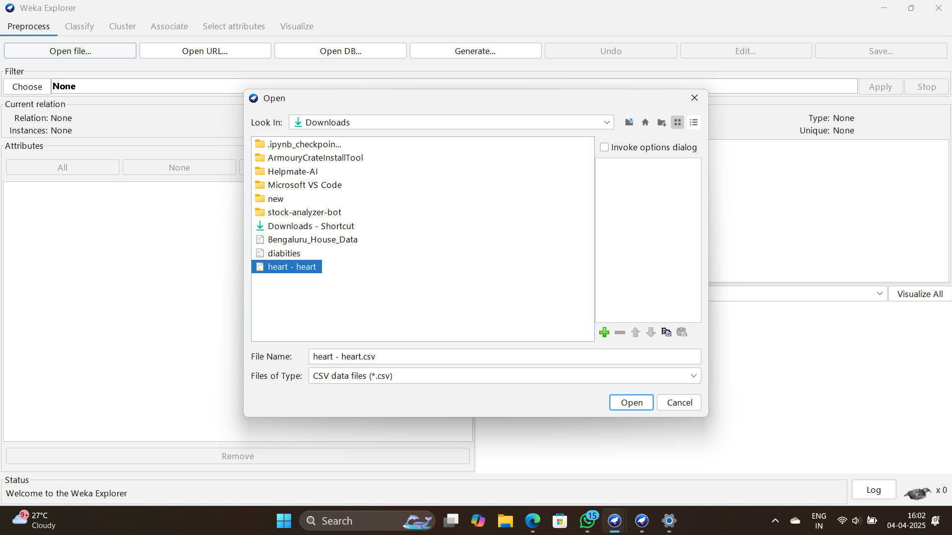

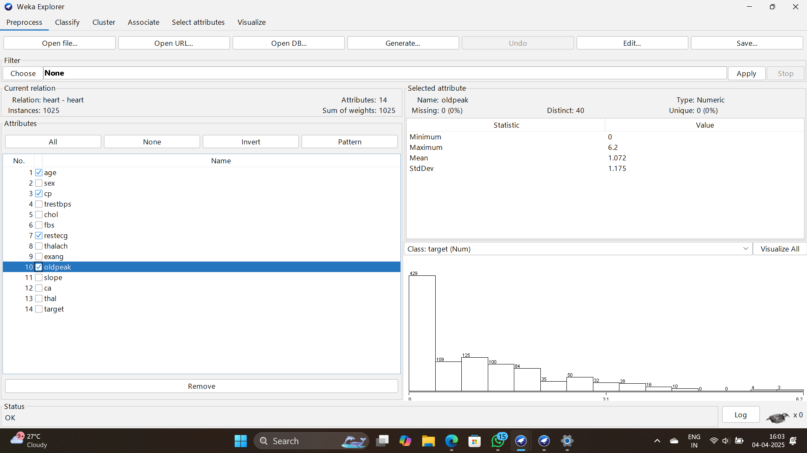

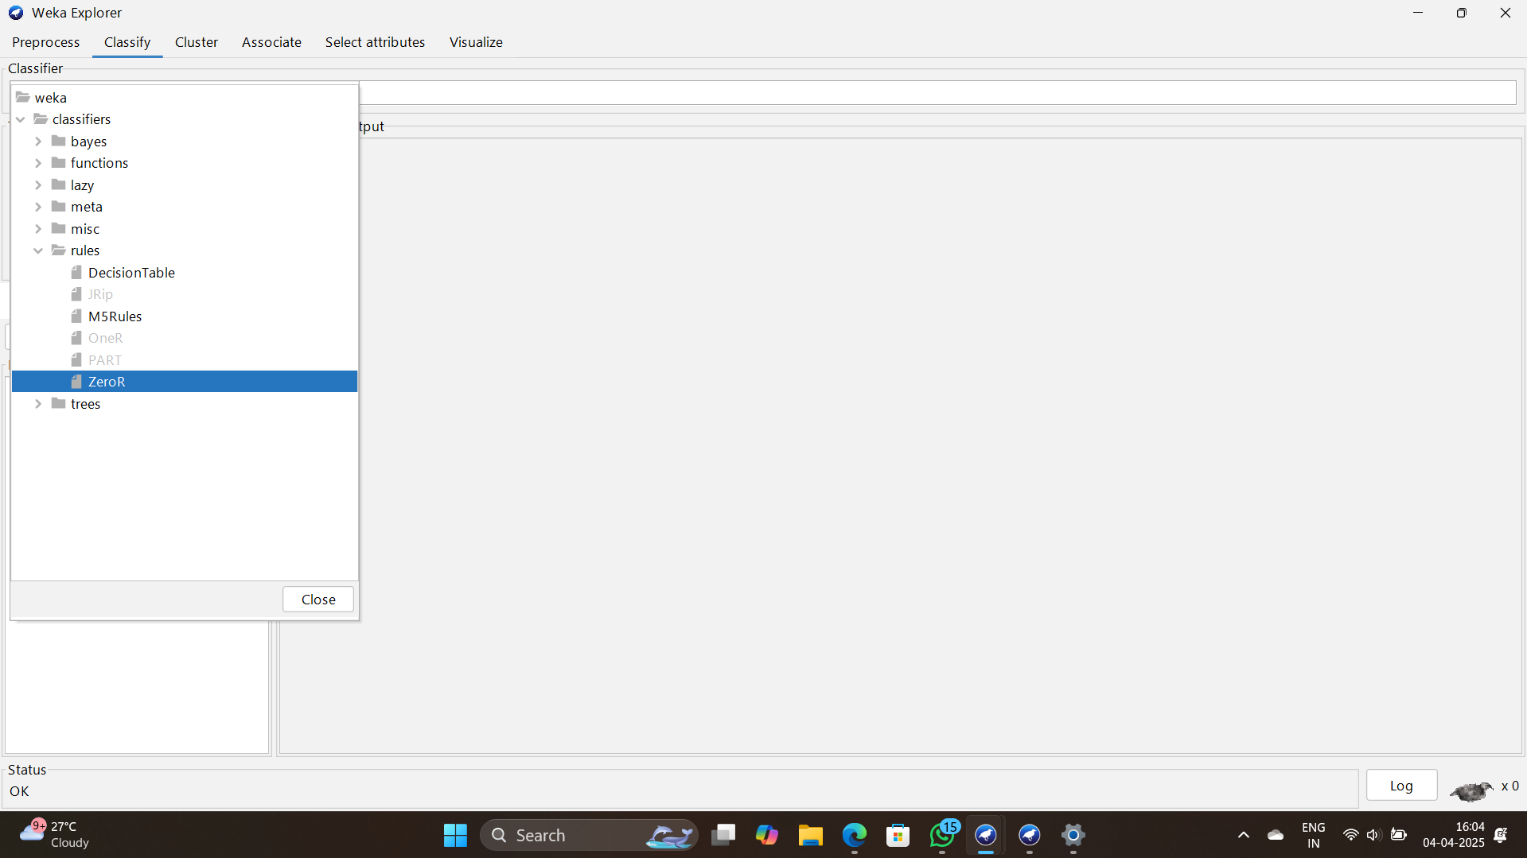

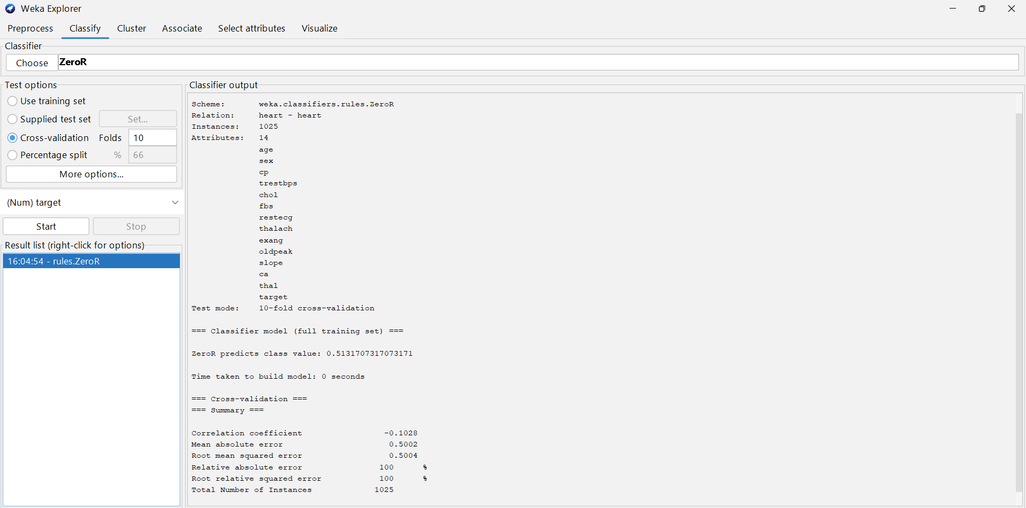

# Observation:

- Weka was successfully installed and launched on the system.  
- The Explorer GUI was used to load a dataset.  
- Basic preprocessing, classification (e.g., using J48 decision tree), and clustering (e.g., k-means) tasks were executed.

# Conclusion:

Weka is a user-friendly machine learning tool ideal for beginners and researchers. Through this practical, the installation process was understood, and the GUI was explored to perform basic machine learning tasks without writing code.

# Result:

Successfully studied and installed the Weka AI tool. Performed basic ML operations using its GUI interface.